SCOPE OF WORK
Electrical Switchgear Service
Zurgovani Residential Complex, Tbilisi

- INTRODUCTION:
The IHOA Zurgovani Residential Complex in Tbilisi, Georgia is seeking contractor proposals to perform preventive maintenance, inspections, testing, and training, on the Zurgovani’ s existing electrical distribution switchgear. This is a one-time service visit. Bidders are asked to schedule the work to occur in two days, beginning after 10AM on working days, with completion no later than 6 PM.
All proposals will be evaluated on a Lowest Priced, Technically Acceptable basis. Technical acceptance evaluation will be based on vendor credentials and work plan. Contractors must submit with their proposals a letter supporting the contractor experience with the associated electrical distribution system as noted in the equipment description within this work statement. Proposals must be presented in a firm fixed price, with itemized costs for all labor, material and travel expenses.

- PROJECT REQUIREMENTS:
Contractor shall provide all supervision, qualified labor, tools, test equipment, noted materials, and training to perform all tasks listed within this work statement. All personnel working in the vicinity of this electrical gear shall wear and /or use the appropriate Personal Protective Equipment (PPE) in performance of this work statement. Any questions or injuries shall be brought to the attention of the Post Occupation Safety and Health Officer (POSHO). As applicable, Material Safety Data Sheets (MSDS) shall be provided by the contactor for all HAZMAT materials.

Follow manufacturer specific maintenance and testing procedures, and general industry practices to ensure operational readiness of the buildings electrical switchgear. Perform cleaning, testing and training on these systems following procedures and general operational requirements for this type of switchgear. The contractor shall include the embassy Locally Engaged Staff (LES) assigned electricians in all aspects of this site work, providing “On the Job Training” (OJT) of the local staff as much as possible. It will be the responsibility of the contractor to explain proper safety and maintenance procedures as part of the OJT training program. No formal classroom training is requested or required.

This one-time service contract is for planned maintenance only. If any discrepancies are found that are not covered under this scope of work then the contractor must provide the following:
  - Detailed report noting the discrepancy found
  - Bill of Materials (BOM) to include component name, quantity, part #, retail price, source, and approximate lead time for any repair material required.
  - Price quote for the estimated repair labor. This should be a not to exceed price and will be contracted separately from this service agreement.

- DESCRIPTION OF EQUIPMENT TO BE SERVICED:
Service includes inspection, testing and cleaning of the existing:
- Merlin Gerin NW20 N1 2000Amp 1EA
- Merlin Gerin NS1000 N 4P Micrologic 2.0 2EA
- Surge Protector, Fuse isolator. 1EA
- Merlin Gerin Compact NS series Breaker 100-250 Amp 14EA
- Merlin Gerin Vigirex RH99P 17EA
- Merlin Gerin Power logic system PM500 3 EA
- Merlin Gerin Multi9 NG125N 1EA
- Merlin Gerin RCDs, MCBs, Fuse boxes. SET

IV. SCOPE OF WORK:
Coordinate site visit service dates with the embassy Facility Manager (FM) and Zurgovani Manager (ZM). Prior to beginning any site work the contractor must submit to the Embassy FM and Zurgovani Manager an isolation Standard Operating Procedure (SOP) and schedule to reflect the planned work and sequence. The contractor must obtain written approval from the embassy Facility Manager noting the planned servicing schedule, and all required generator transfers or switchgear outages.
Provide basic consumable parts associated with the service and maintenance of the switchgear listed in section III. This must include, but not limited to, batteries for the trip units, fuses, and dielectric lubricant. Correct any faulty, damaged, discolored, and worn components. Provide a part number and retail price for any noted deficiency found that cannot be corrected during this site visit. Note the faulty equipment or deficiency in a final service report. All follow-on repair action and material will be covered under a separate scope of work. At a minimum this service shall include the following: A. Step-One, Visual Inspection:
1) Visual and Mechanical Inspection to ensure the proper operation of all factory and vender installed meters, breakers, power monitoring equipment associated with the switch gear.
2) Inspect physical, electrical, and mechanical condition including evidence of moisture or corrosion.
- Inspect that all filters are in place, and the vents are clear.
- Inspect that the electrical room is free from foreign articles not associated with the room.

B. Step-Two, Verify:
- Compare the installed metering measurements with voltage and power readings from a True RMS meter. Make calibration corrections as necessary to ensure accurate voltage and power readings.
- Verify the switchgear circuit breakers sizing.
- Verify the proper labeling of all the breakers in the switchgear and correct if necessary.
- Verify the build drawings (electrical one-line) match the switchgear distribution. Make “Red Ink” corrections on a paper, copy as necessary. Inform the Zurgovani Manager (ZM) of any discrepancies or changes to the drawings.
- Verify that the safety equipment is available and in good condition for local staff to use.
- Refer/Research the manufactures recommendations for additional maintenance requirements.

C. Step-Three, Test/Clean/Correct:
- Inspect anchorage, alignment, grounding for the equipment.
- Test the system earth ground (25 ohms or less).
- Perform infrared testing on all conductor connections, buss terminations. Only record found hot spots on a digital format for review.
- Conduct an operational test of the system, observing automated transfer to and from generator power unit.
- Ensure that all components are operational, record noted discrepancies. Make the ZM aware of all components that are not functioning prior to shut down.
- Schedule power outage of equipment for cleaning. Perform Lock-out/Tag-out and ensure the system is de-energized before removing panel covers and exposing any electrical bus or cabling. Under no circumstances should the equipment be energized during the maintenance operation
- For breakers inspection; perform function tests using external power, test trip units and settings. Replace any faulty battery, fuse, or switch.
8) Clean each compartment. Check for damage, excessive wear, or corrosion
9) Spot check and correct any loose components or connections.
- Torque loose connections identified during the infrared test or during inspection.
- Confirm correct operation and sequencing of electrical and mechanical interlock systems.
- Use appropriate dielectric lubrication on moving current-carrying parts and on moving and sliding surfaces.
- Correct any faulty, damaged, discolored, and worn components.
- Exercise all active components.
- Inspect mechanical indicating devices for correct operation.
- Inspect power control transformers for physical damage, cracked insulation, broken leads, tightness of connections, defective wiring, overload protection, and system condition.
- Conduct a thorough safety inspection prior to removing locks/tags and re-energizing equipment. Upon restoration of power verify configuration and normal system operation.
- Refer to the manufactures suggested recommendations for additional maintenance requirements, required or recommended. Conduct these accordingly.
- Make calibration corrections as necessary to ensure accurate voltage and power readings on permanently installed switchgear metering.

GENERAL REQUIREMENTS:
This section outlines the general requirements of this contract, regarding security, travel, deliverables, and other site requirements.

Service Requirements:
  - The contractor shall furnish and utilize a maintenance checklist or product worksheet to document inspection, testing, and servicing results for each breaker and ATS required under this work statement. These checklists must be included in the final report.
  - The Embassy FM and ZM must be made immediately aware of any condition discovered that could result in equipment failure, or inhibit the equipment from being put back into service.
  - All power transfers and system outage work must occur during Embassy work hours.
  - The contractor must clean up after each task and place all maintenance associated trash in the proper dumpster or approved trash container.

Safety Requirements: Safety is the highest priority on this job. The contractor shall direct all of those under his/her charge to work safely. All local safety regulations and standards must be maintained at all times. Regular safety meetings shall be held among on-site contractor personnel. Safety concerns shall be brought to the attention of ZM.

Deliverable Requirements: The contractor shall provide one copy of a typed summary report within 10 days of site work statement completion. The report must be written in the English and Georgian language. At a minimum the report must include the following:
  - Provide an executive narrative summary that provides an overview of work completed and immediate follow-up action required.
  - Provide a detailed report per equipment serviced that includes all findings, corrective measures taken, inspection/testing checklists.
  - Discrepancies found and include photos of the problem and a narrative summary of the corrective action required. The repair action will be contracted separately.
  - Provide a Bill of Materials (BOM) as necessary for any required repair parts for future corrective action or repair. The BOM must note component name, part #, vendor or source, approximate lead time, suggested retail price.
  - Provide a separate Bill of Materials (BOM) as necessary for any recommended spare parts for system.

Security Requirements: The contractor will be escorted whenever necessary.

Travel Requirements: Submit proposed site visit dates with price proposal and work plan. The contractor shall under no circumstances incur any travel or other costs, or begin travel to the site or work at site until a signed purchase order is issued and country clearance is granted. Once all needed material is onsite, visit dates will be finalized between the contractor and Zurgovani Manager.

Submission procedures:

Interested candidates can contact via mobile phone or Email listed below:
Contact Person: Giorgi Ramishvili
Mobile: +995 599 76 25 33
E-mail: villagediplomatic@gmail.com
Address: Tbilisi, Village Zurgovani

Interested candidates should send as an attachment General Information of the Bidder:
- Company Name:
- Address:
- E-mail:
- Contact Person:
- Telephone:
- Director Name:
- Company ID:
- Years of experience:

Attachment –A:

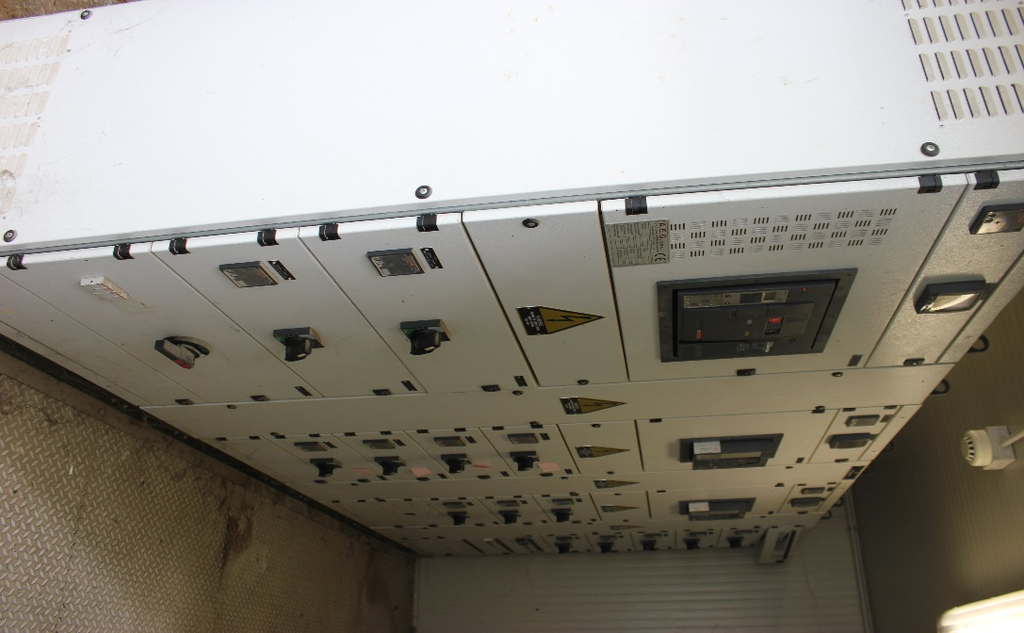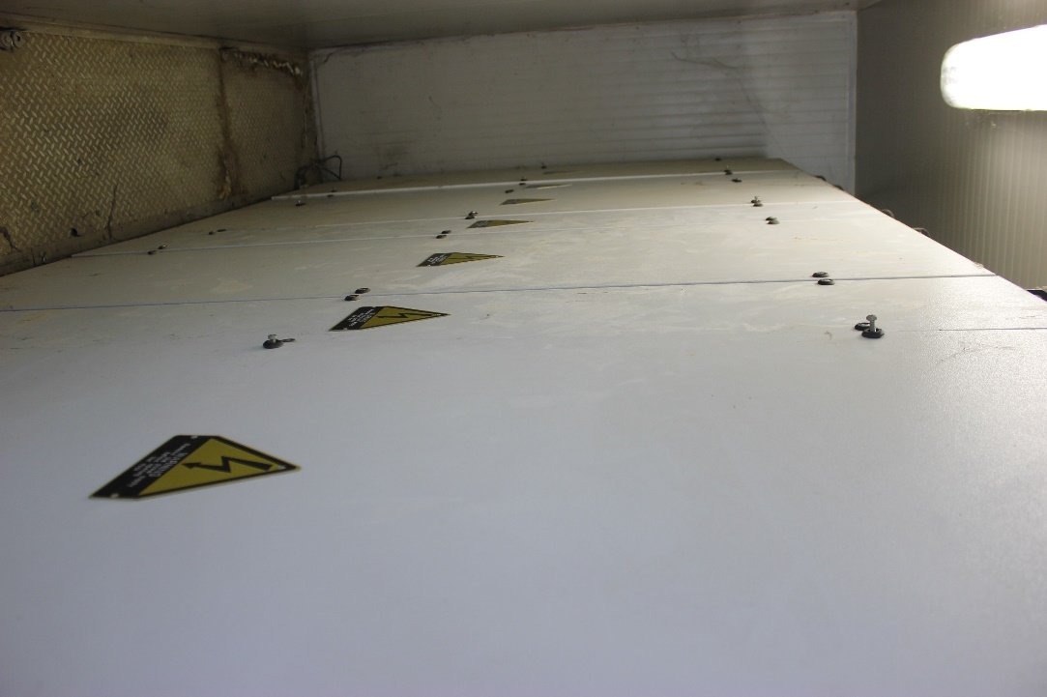

Main Distribution Switchgear

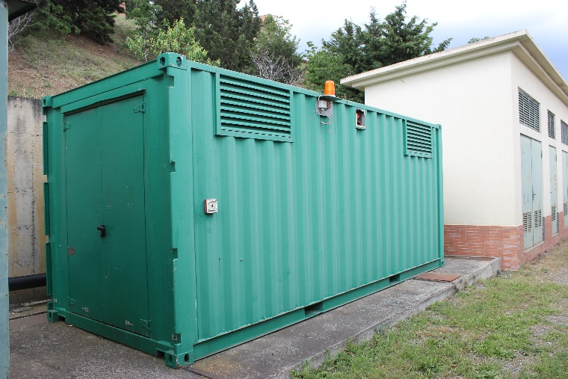

Main Distribution Switchgear container

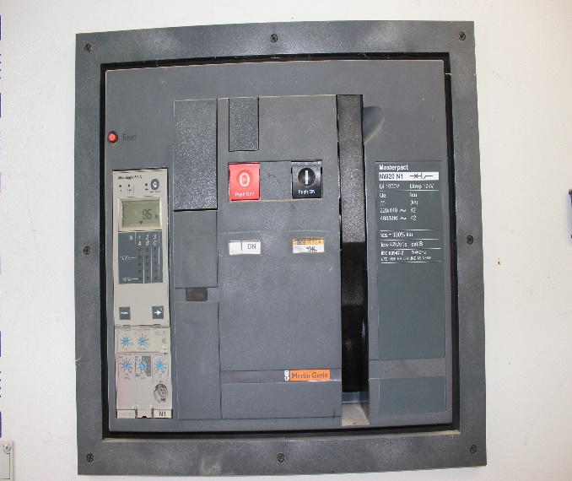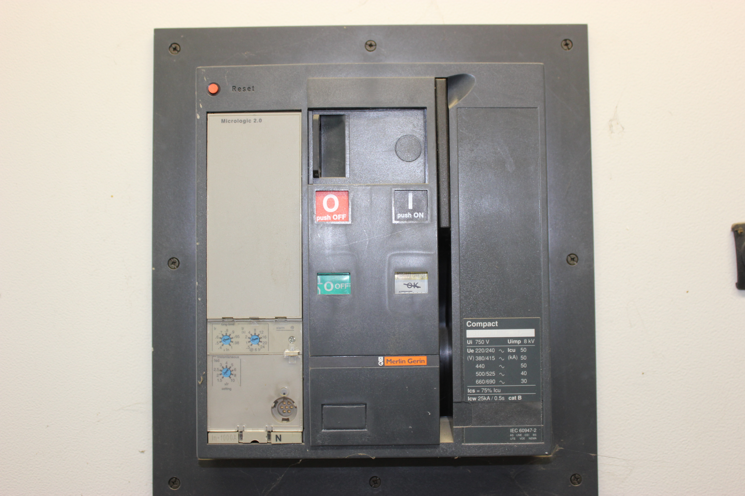
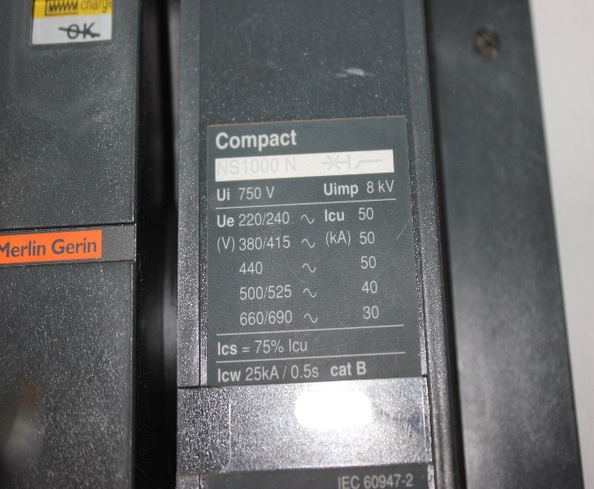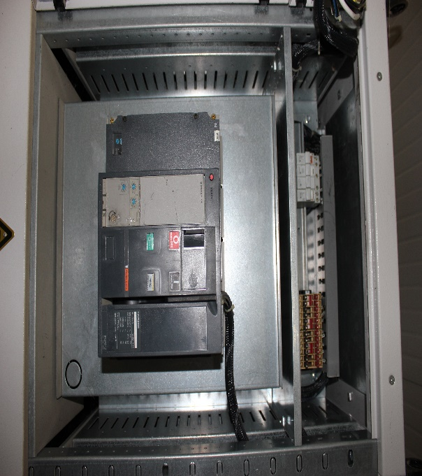

Merlin Gerin Breakers

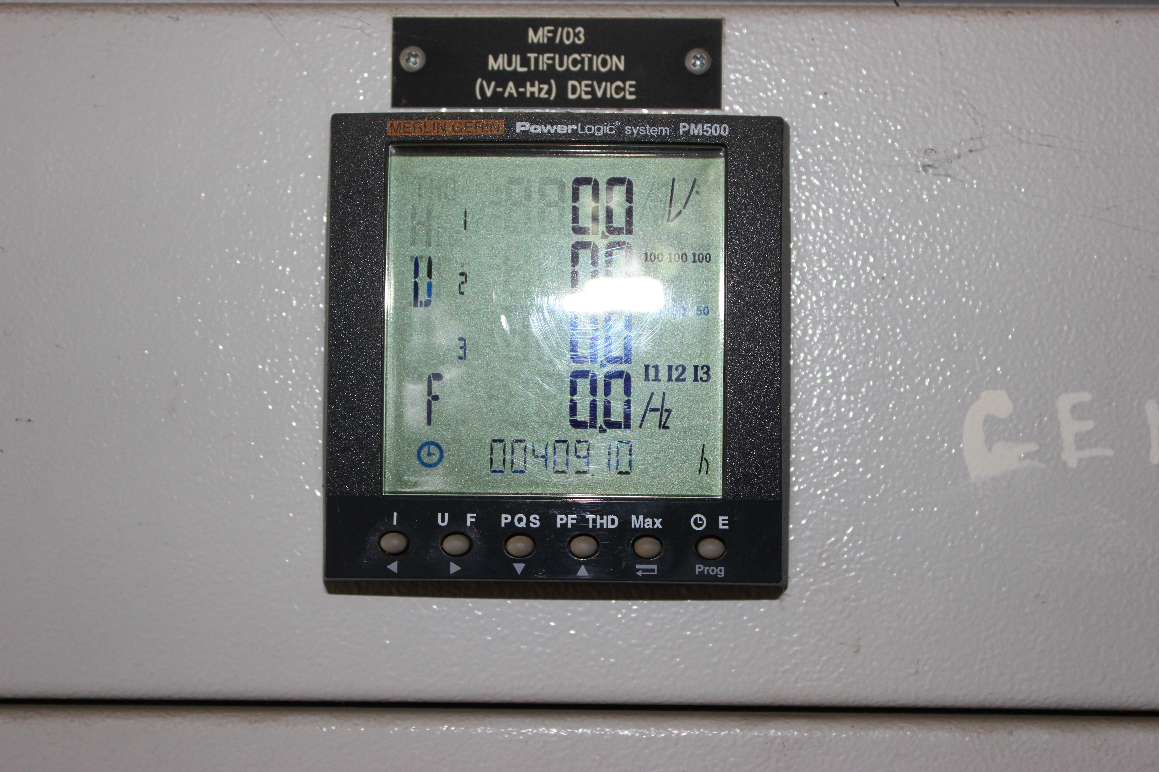

Power logic

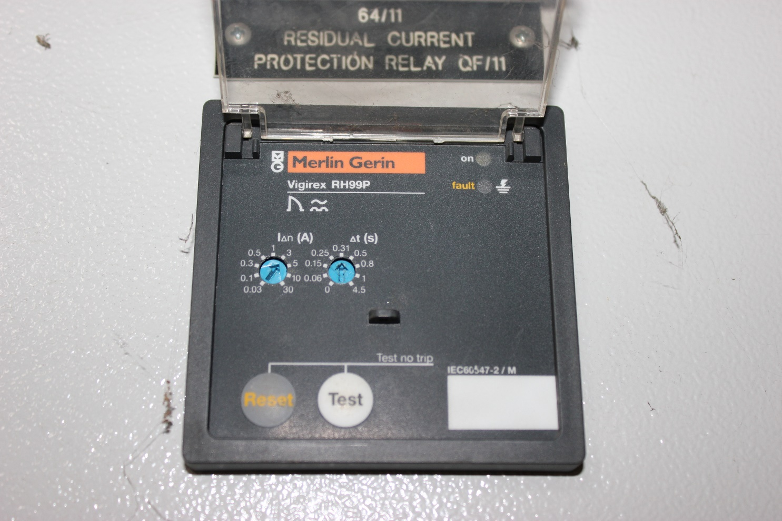

RCD

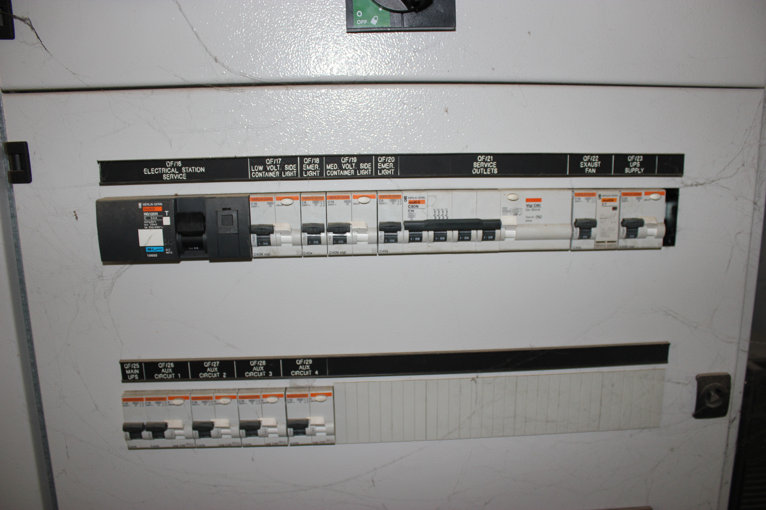

Merlin Gerin RCD and MCB set

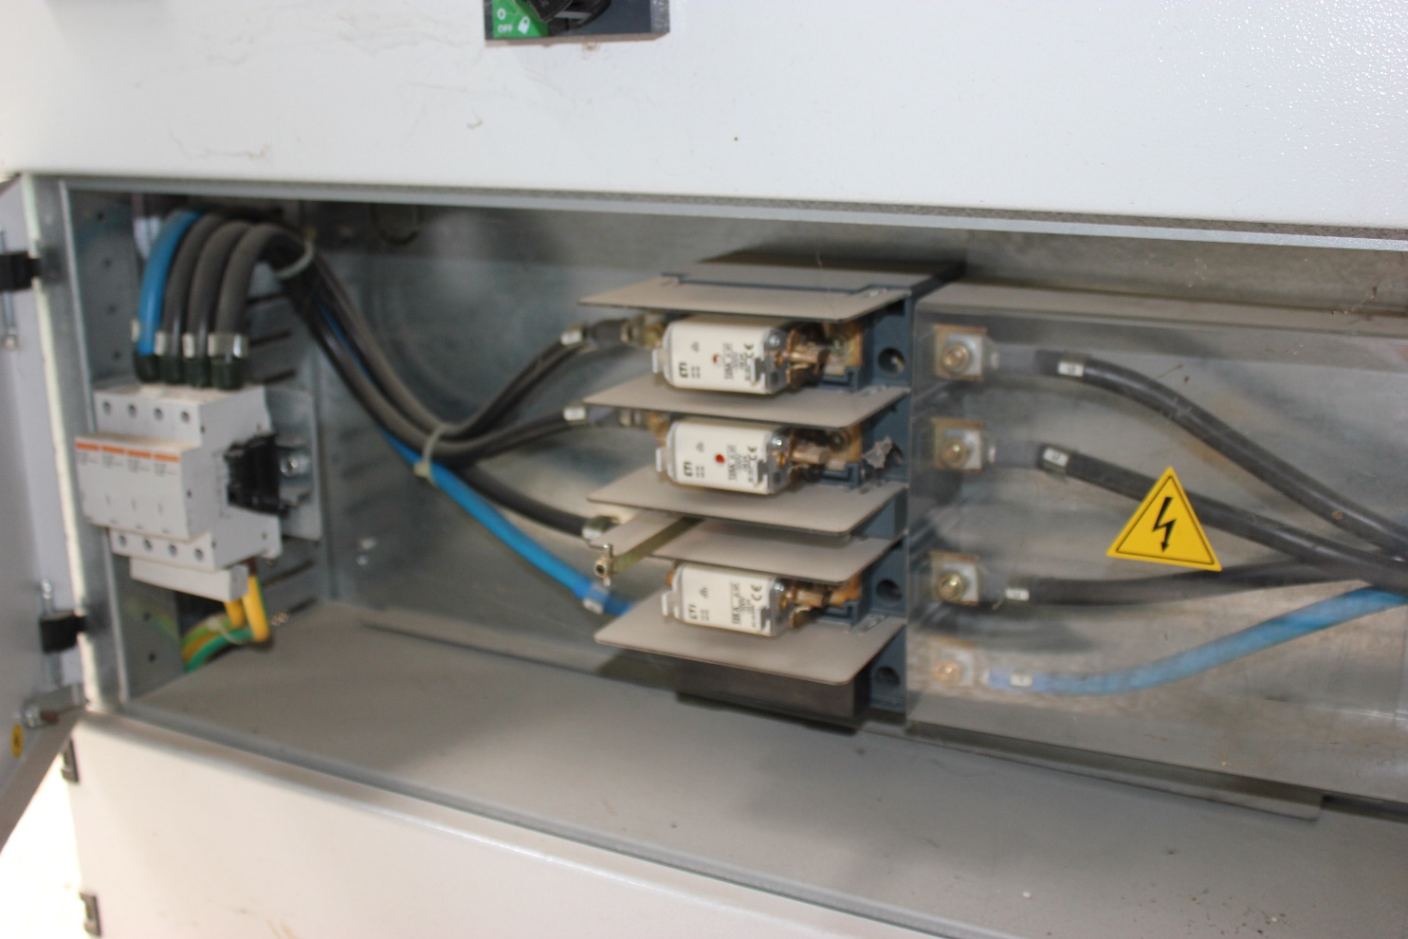

Surge Protector, Fuse isolator

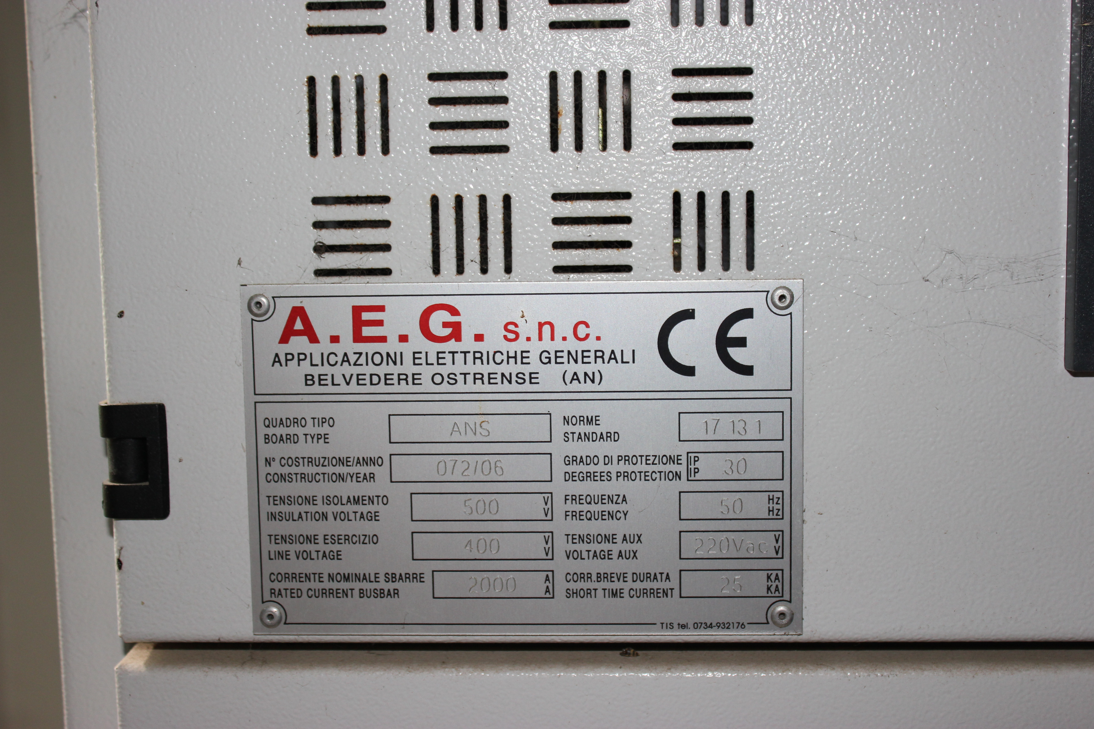

Switch gear enclosure technical tag

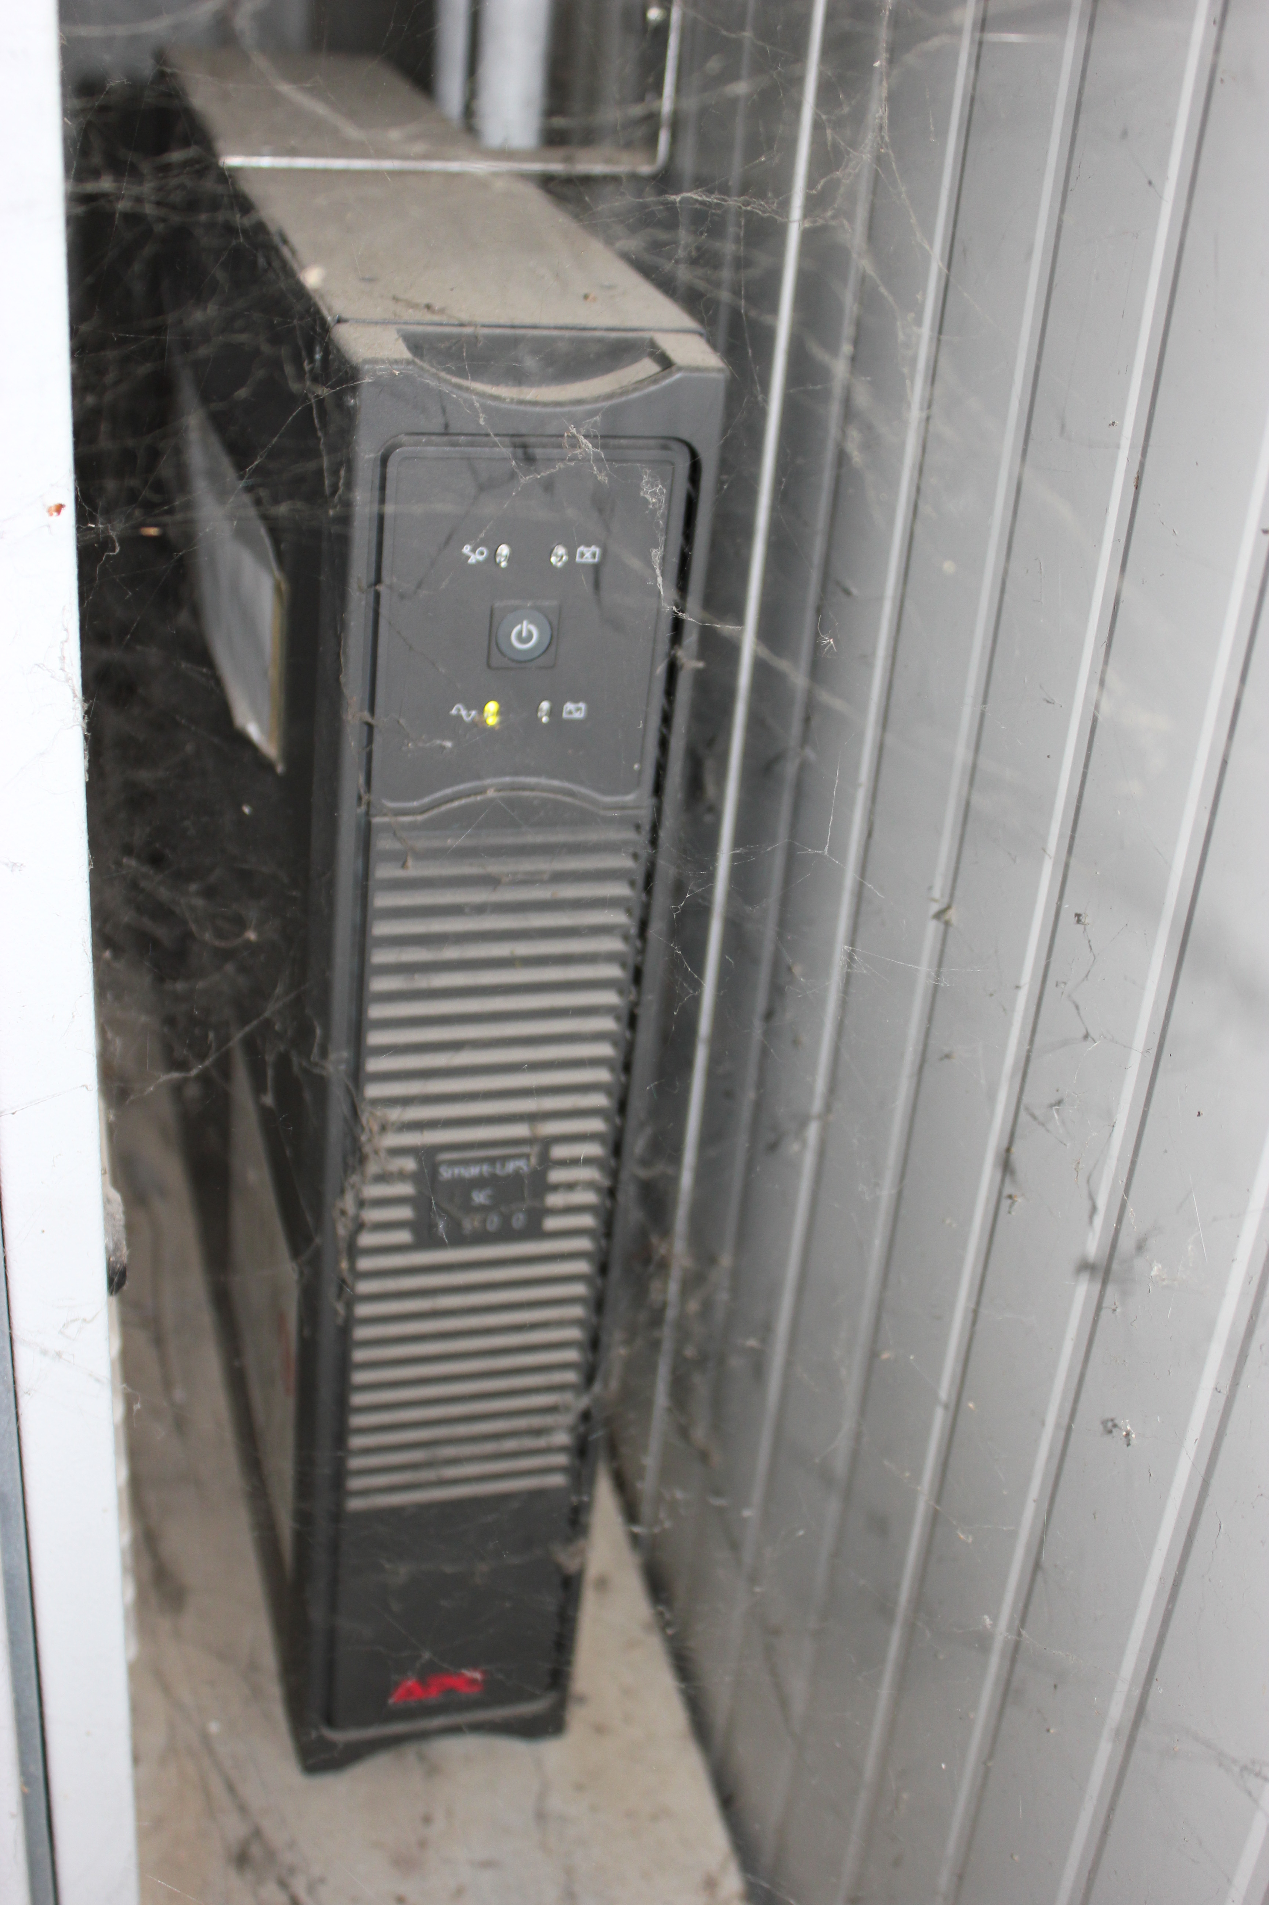

UPS

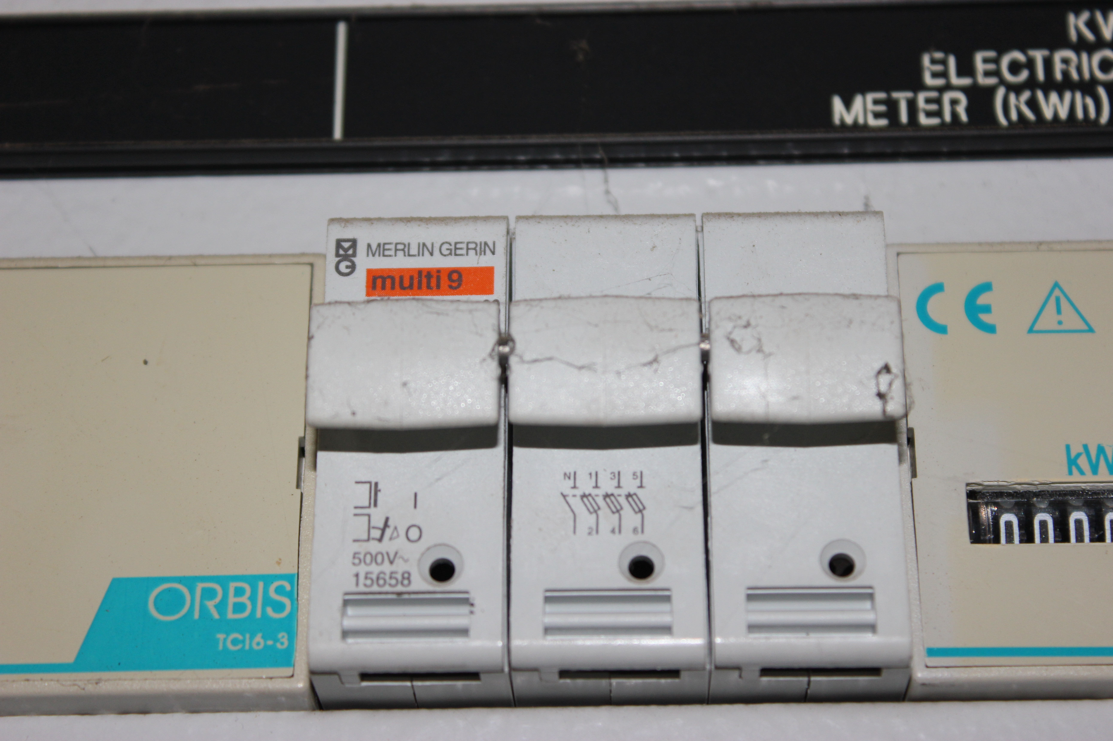

Merlin Gerin Fuse box

